Application for the
CSL Behring – Prof. Heimburger Award
in the area of coagulation

Name of applicant: ...............................................................................................................................
Sex: female male
Date/place of birth: ..............................................................................................................................

Medical degree obtained: ...................................................................................................................
(title, year and place)

Hospital/Institution: ............................................................................................................................. (name and address)

................................................................................................................................................................
Title of research project: ......................................................................................................................
................................................................................................................................................................
E-mail address for contact: ..................................................................................................................
Other involved scientists:

Name | First name | Academic title | Brief description of involvement in research project

Herewith I confirm that I have read and accept the eligibility as well as the details regarding the application procedure.

Please include the following documents:
- Short CV (max. 1- 5 pages)
- Research proposal (one-pager incl. name and institute)
and return them to the following address:

CSL Behring GmbH
Att. Dr. Birgit Voelker,
Medical Affairs Commercial Development Hematology & Thrombosis
Emil-von-Behring-Strasse 76
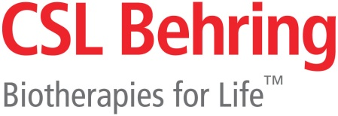
35041 Marburg
Germany
T: +49 151441624 8 3
E-mail: Heimburger.Award@cslbehring.com

